# FUZZY LOGIC PROJECT

|  |  |
| --- | --- |
| Muhammed Ramazan Kılıç | 14290105 |
| Abdullah Gür | 14290100 |
| Yunus Çiftçiler | 14290084 |

The Structure of Project

1. Fuzzy Numbers Class

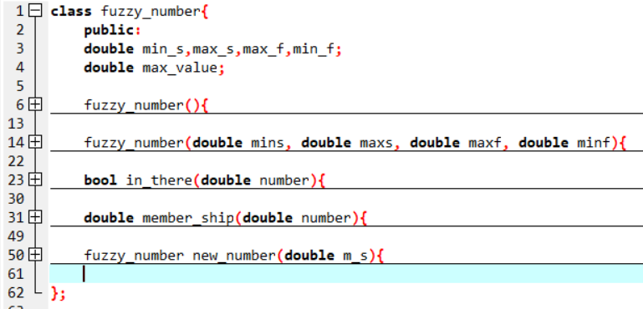

This class structure is used to define fuzzy numbers generically. New_number function in this class is used when we produce a new fuzzy number from the basic structure.In_there

2. Person Structure

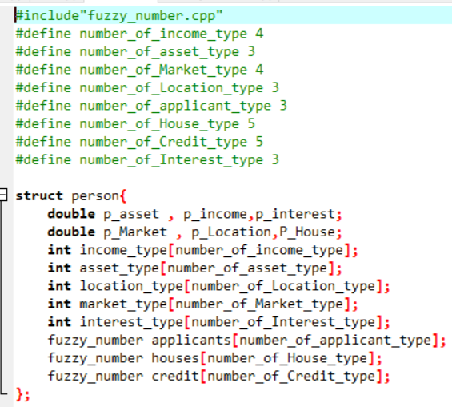

There may be so many users who want to learn how much credit they can take.So Person structure is used for this purpose.

3. Rule Functions

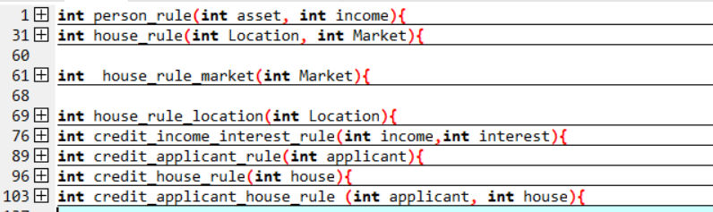

The functions of rules will be considered to find credits

4. Input Member-Ship Values and Functions

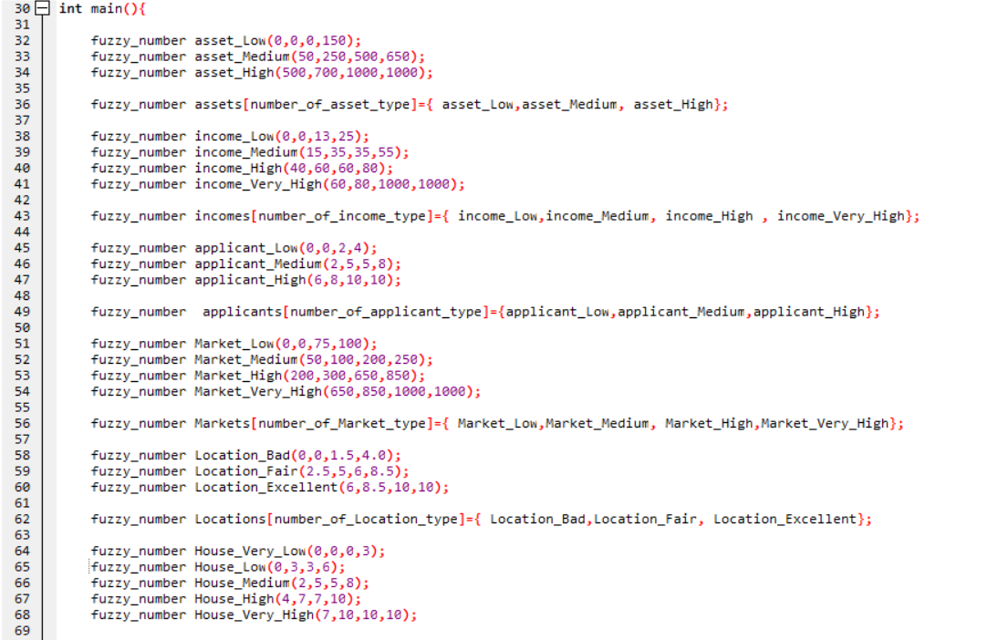

Fuzzy number input values are added into arrays.

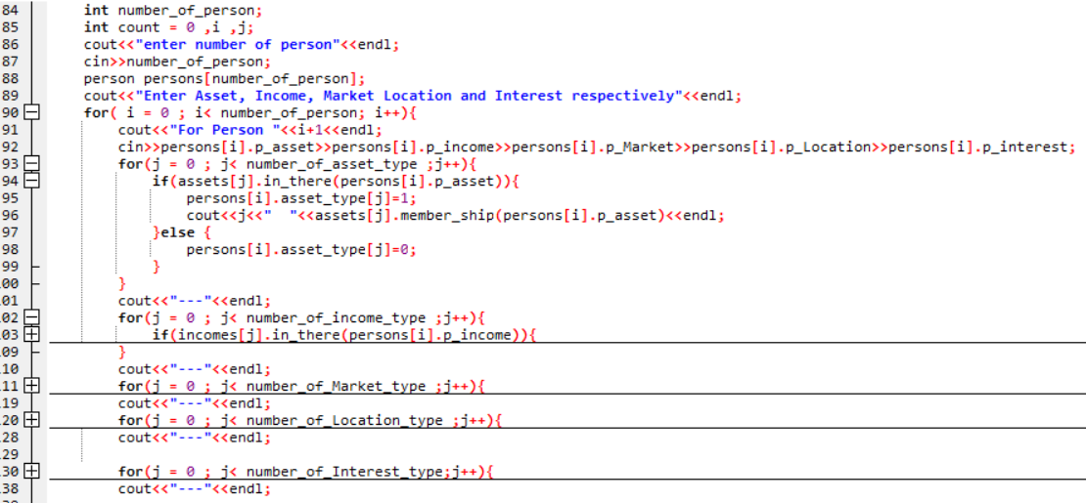

The values of the types in the arrays are founded in this section according to the input values are given at first.

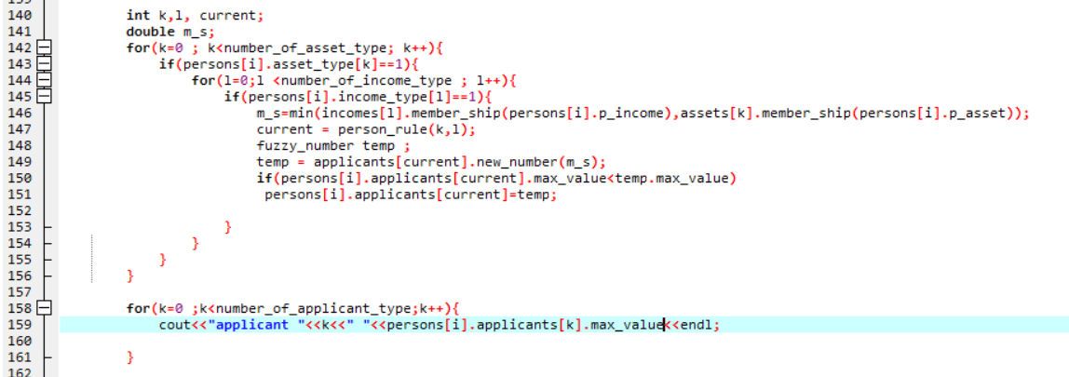

In this section, we find the values of applicant array from person rule.

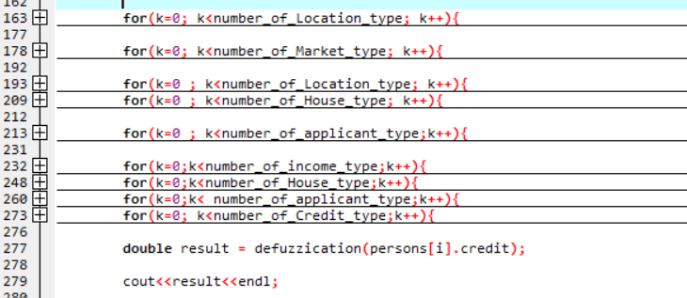

As we found the values of applicant array , we find the values of House and Credit arrays from the rule functions.

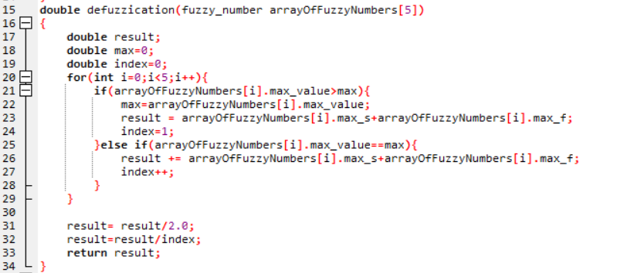

After we found Credit array of a person from all these processes ,we send this array to defuzzication function to get a crips value.And this crips value represents our credit.Defuzzication function uses MOM (Mean of Maxima) method.

5.Input-Output

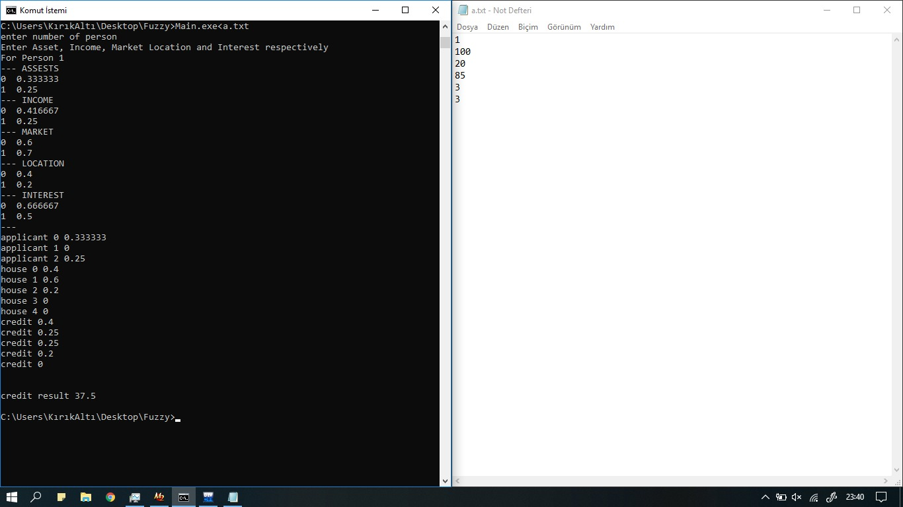

a.txt file in the Picture is our input file for the Project.

The first parameter is number of users.

The second parameter is Assest values

The third parameter is Income values

The fourth parameter is Market values

The fifth parameter is Location values

The sixth parameter is Interest values

The consol screen is output

There will be so many screen like this if we have so many users. In this Picture we have only one user.

Assest types are Low ,Medium and High . This are respresented in the asset array as integer values like 0 means “Low”, 1 means “High”..

According to the input values we founded types of arrays and their membership values.After that,we founded also the values of applicant,house and credit arrays.

As last ,credit arrays are sent to defuzzication and it gives us a crips value of our credit.